**SUZAN MOLLA**

muhammad.suzan.01@gmail.com

/in/suzan-molla





+8801768868987

House no. 13, Road no 06, Block B, Banasree, Rampura, Dhaka, Bangladesh.

* 



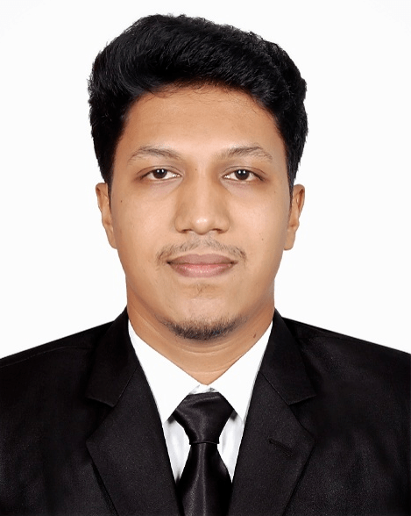

**CARRIER OBJECTIVE**

Profoundly engaged, confident, devoted, with a strong sense of values, enthusiasm for reality, and passion for equity looks to set up a profession with a significant law office resolved to maintain and use the original capacity of the law and to handle the entire legal issues into the company, Draft and oversee any dealings and agreements the corporation concerned with.

**JOB EXPERIENCE**

**Legal Officer**

At **PRAN-RFL Group**

March 2021 – Current

**JOB RESPONSIBILITY**

* Research case file & prepare for filing law suit.
* Dishonor defaulter cheque.
* Check legal notice & feedback to panel lawyer.
* Check case draft & feedback to panel lawyer.
* Drafting GR case.
* Making monthly court attendance.
* Regulate and follow up all the case and do all the function of law suit.
* Agreement vetting & provide legal opinion.
* Making compromise deed.
* Write notice on behalf of the company.
* Write notice and send to DB, CID, PBI, Police Station & various governmental organization.
* Assisting the head of legal for vetting land document.
* Making chain of ownership of land.
* Check all the dag, khatian of land.
* Registration of land on behalf of the company.
* Submission for mutation.
* Payment of Land Tax on behalf of company.
* Assisting head of legal to all the function of criminal & land related work.
* Do all the work assign by the company.

**Legal Associate**

At **Primus Legal** (A Legal & Corporate Consultancy Firm)

December 2020 – March 2021

**JOB RESPONSIBILITY**

* To Prepared the Case File Specially Artha Rin Suit.
* To Prepared Summon.
* Maintain The Case Diary.
* To prepared legal notice, case draft, Hajira, Time Petition & other court related work.

**PERSONAL DETAILS**

* **Date of Birth:** March 10, 1997
* **Nationality:**  Bangladeshi
* **Religion:** Islam
* **Sex:** Male
* **Present Address:** House no. 13, Road no 06, Block B, Banasree, Rampura, Dhaka, Bangladesh.
* **Permanent Address:** Jakerer Dangi, sadarpur, Faridpur, Bangladesh.

**ACADEMIC CREDENTIALS**

Bachelor of Law **(LL.B)**

**East West University**

**CGPA: 3.01 out of 4.00** (Average **80%** marks as per university grading system)

January 2016 - October 2020

Higher Secondary Certificate **(HSC)**

Tejgaon College (Dhaka Board)

Humanities

GPA: 3.25 out of 5.00

July 2013 - August 2015

Secondary School Certificate **(SSC)**

Nayadangi High School, Faridpur (Dhaka Board)

Humanities

GPA: 3.63 out of 5.00

January 2011 – May 2013

* Founding Secretary at **Bondhon Foundation.** (Since 2020) (A voluntary organization work for the development for the society).
* Member at **Bangladesh Lawyers and Law Students Association.** (Since 2017)(One of the largest association for lawyer and law students)
* Was a general Member at **East West University Photography Club.** (2018-2019)
* Was a general Member at **East West University Law Club.** (2017-2018)

**EXTRACURRICULAR ACTIVITIES**

* 1st language- **Bengali**
* Academic Language-**English**

**LANGUAGE PROFICENTEY**

**PROFESSIONAL SKILLS**

* Can manage difficult situation.
* Can work with Team.
* Can work under immune pressure.
* Communicate easily with different people.
* Can negotiate easily with different kinds of People.



Suzan Molla

**Md. Mahabubur Rahaman**

Advocate

Supreme Court of Bangladesh

Email: Mahabuburrahman.d@gmail.com

Mobile: +8801718325279

**REFERENCES**

**Fariha Abedin**

Senior Lecturer

Department of Law

East West University

Email: [fariha@ewubd.edu](mailto:fariha@ewubd.edu)

Mobile: +8801947535331

**RESEARCH PAPER**

**Extra-judicial Killing and Human Rights: A Critical Analysis under Bangladesh Perspective.**

* **Workshop on Legal Research and Advocacy Skills** Organized by**: The Network for International Law Students Bangladesh**. (mainly focus on how to write legal research in the proper way)

**TRAINING / WORKSHOPS**

* Microsoft Office (Word, Excel, PowerPoint)
* **Wordpress**
* **HTML**
* **CSS**
* **Bootstrap**
* **JQuery**
* **Skilled at professional Web design**

**COMPUTER SKILLS**